2.34: After the initial acceleration, the train has traveled

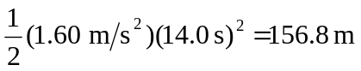

(from Eq. (2.12), with x₀ = 0, v_{0x} = 0), and has attained a speed of

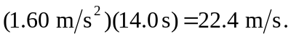

During the 70-second period when the train moves with constant speed, the train travels 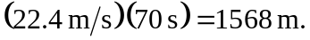 The distance traveled during deceleration is given by Eq. (2.13), with 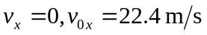 and 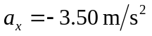, so the train moves a distance 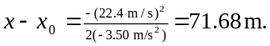 The total distance covered in then 156.8 m + 1568 m + 71.7 m = 1.8 km.

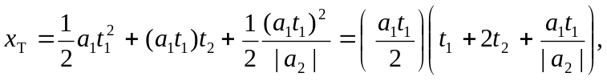In terms of the initial acceleration a₁, the initial acceleration time t₁, the time t₂ during which the train moves at constant speed and the magnitude a₂ of the final acceleration, the total distance x_{T} is given by
which yields the same result.

